Seniors Stay Healthy with SNAP
This toolkit provides social media captions and images that can be used to promote SNAP to seniors and their caregivers.

Images/Graphics:
- Right-click on an image to save it to your computer
Sample Messages:
- Copy and paste the text and pair with an image.

Images/Graphics:



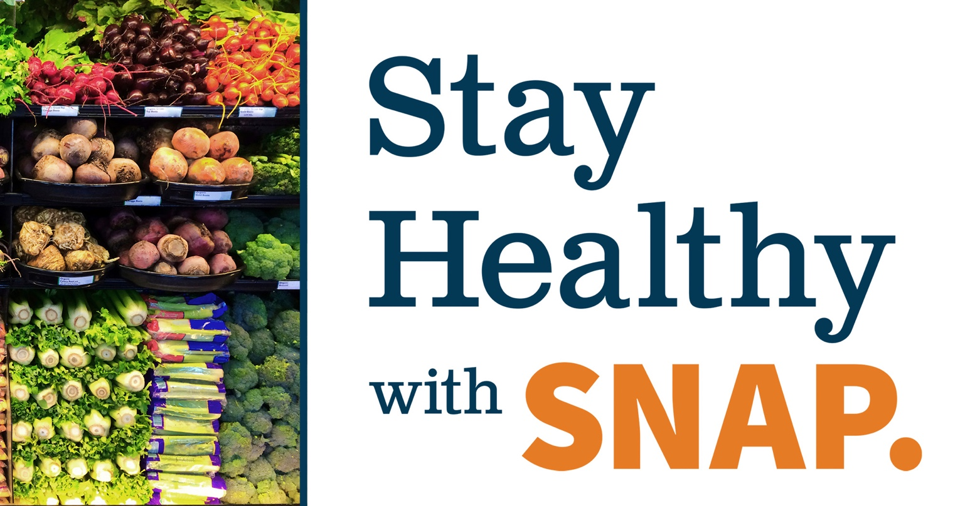

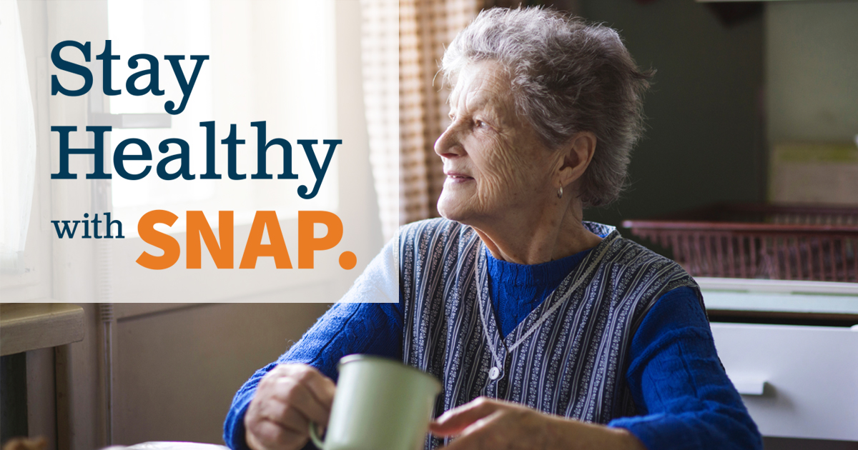



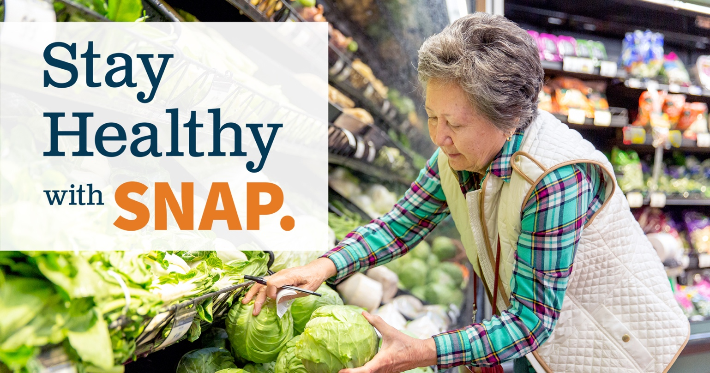

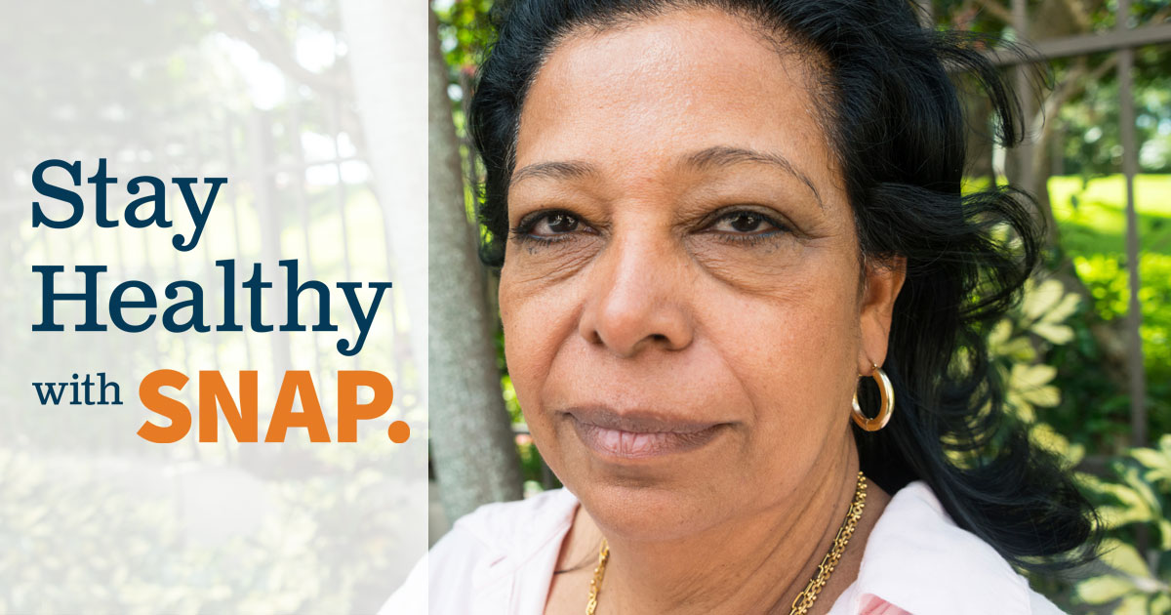

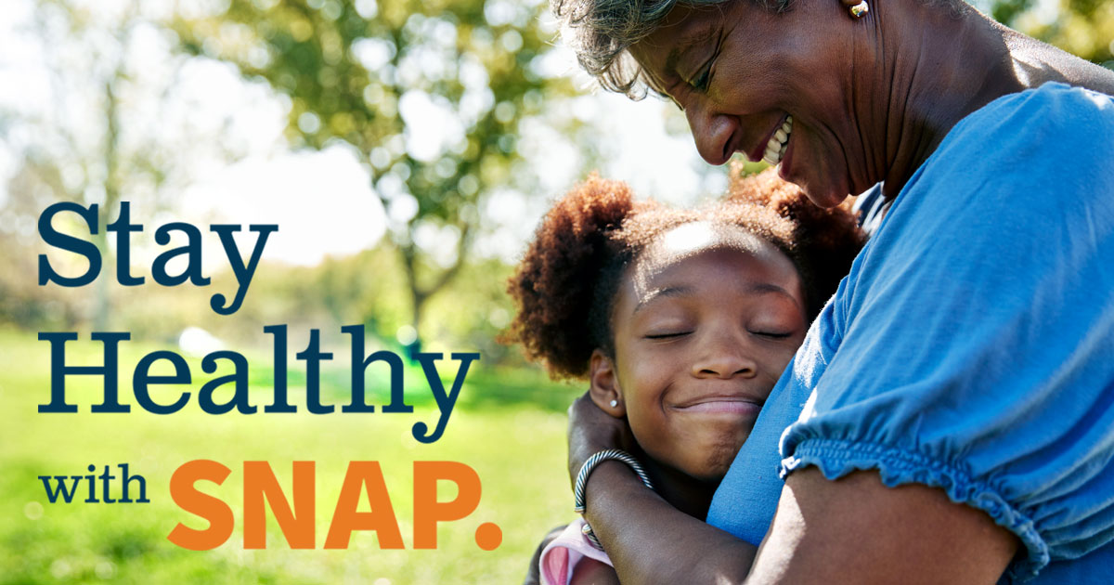

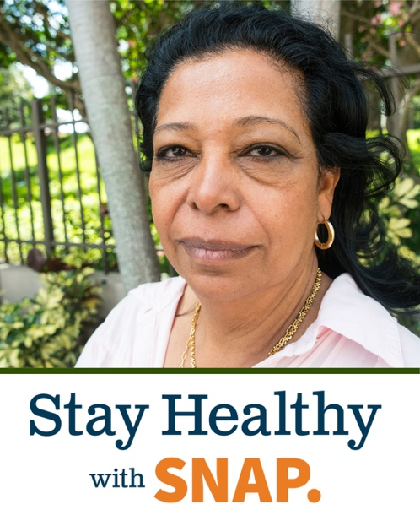
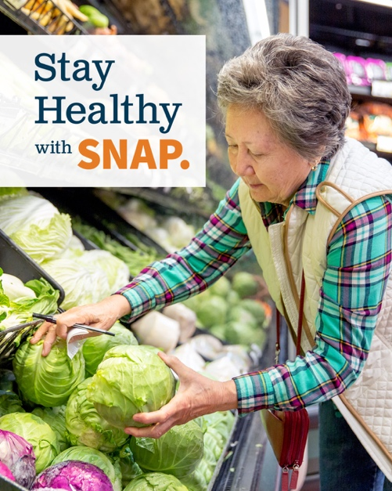

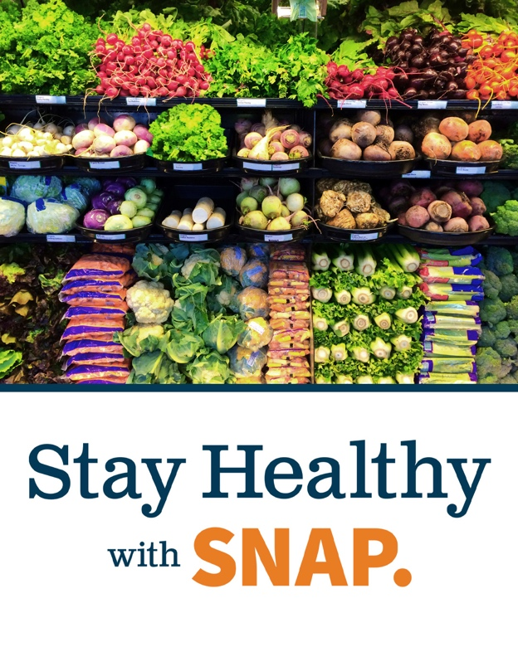


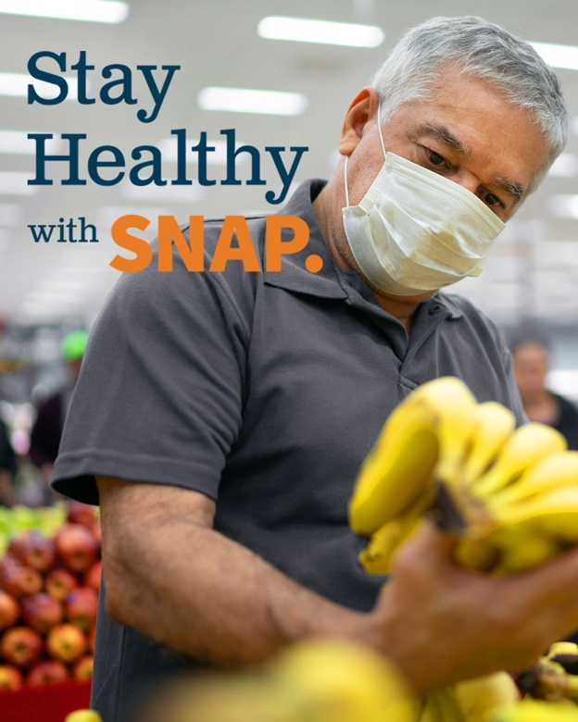


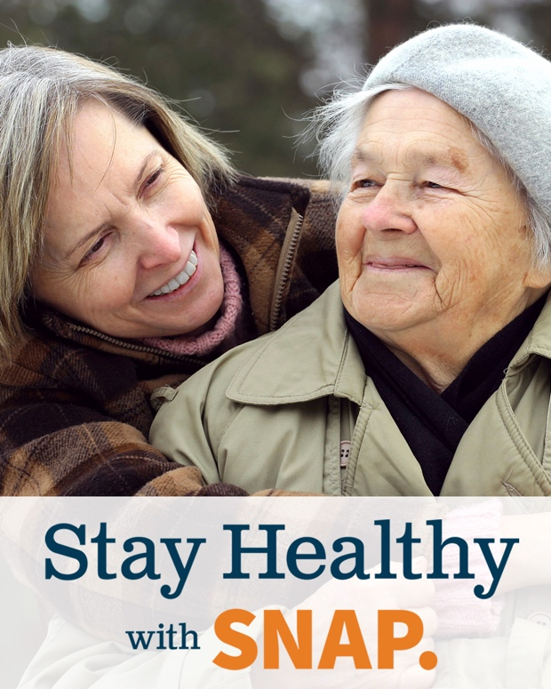

Sample Messages:
SNAP helps more than 600,000 seniors in New York State stay healthy by improving their nutrition and food security. If you or a senior you know struggles with hunger, visit FoodHelpNY.org to find SNAP assistance.

Many seniors rely on SNAP to put food on the table. SNAP is like Social Security and Medicare—if you are eligible and apply, you will get your benefit and have more to spend on food. If you struggle to get enough food, visit FoodHelpNY.org to learn how to get started with SNAP.

SNAP helps more than 600,000 seniors in New York put food on the table, but many eligible seniors do not participate. If you or a senior you know struggles to afford food, visit FoodHelpNY.org to learn how to get started with SNAP.

Do you work with seniors? SNAP helps hundreds of thousands of seniors in New York buy groceries, but many who are eligible do not participate. Visit SNAPandSeniorsNY.org for tools and resources to help connect more seniors to SNAP.

SNAP puts nutritious food in reach of more than 600,000 New York State seniors. Using SNAP is easy, and special rules can help more seniors apply and participate. To learn how to get started, visit FoodHelpNY.org.

SNAP helps thousands of New York State seniors access nutritious food. With an EBT card to buy food and special rules to help more seniors apply, using SNAP is easy. Learn how to get started at FoodHelpNY.org.

Too many seniors in New York struggle to get enough to eat. SNAP helps seniors afford a nutritious diet that supports a healthy lifestyle. Visit SNAPandSeniorsNY.org to learn more and find tools and resources to connect seniors to SNAP.

